2Lab 2 – 1st Iteration
Project: Amplio - Collaborative Music Playlist Platform
New feature: Friend System
Team: Vilkai

Context

System Description
Amplio is a collaborative music playlist platform. The backend is built with .NET 8 / ASP.NET Core and exposes a REST API, the frontend is a React single-page application, and data is stored in PostgreSQL via Entity Framework Core. Users authenticate with JWT bearer tokens (HMACSHA256, 12-hour expiry).

Current System Boundaries
The system currently supports the following features:
User authentication — registration and login with password hashing (HMACSHA256 + salt) and JWT token issuance. Playlist management — users can create public or private playlists, and add, remove, or upvote songs within them. Concurrent voting — vote updates are serialised using a SemaphoreSlim with counts cached in a ConcurrentDictionary to reduce database load. Playback queue — setCurrentSong() promotes the top-voted song to the active slot and removes it from the queue. Leaderboards — GenericLeaderboard<T> ranks playlists and albums by popularity. Song catalogue — songs are loaded from a local JSON file, each song has a normalised YouTube URL (SongLink) and one or more Genre values.

Planned Change — Friend System
This iteration adds a Friend System to the platform. The following capabilities are introduced:
Friend request lifecycle — a user can send, cancel, accept, or decline a friend request. Requests move through the states Pending → Accepted | Declined | Cancelled | Blocked, tracked by the FriendRequestStatus enum. Persistent friendships — accepting a request creates a Friendship record between two users, removing a friend deletes it. Blocking — a Block record stops the blocked user from sending new requests and hides the blocker's profile and playlists from them. User search — users can search by username, blocked accounts are excluded from results. Playlist invitations — a playlist host can invite friends directly, without needing to share a join code.

Technical Constraints and Assumptions
The three new entities (FriendRequest, Friendship, Block) will be added to the existing AppDbContext and introduced via EF Core migrations — no changes to existing tables are needed. All Friend System endpoints require JWT authentication. Performance-wise, friend operations should complete within 1 second and user search within 2 seconds, indexed foreign-key columns (SenderId, ReceiverId, UserId, FriendId) make this realistic. Rate limiting for friend requests (20 per user per hour) will be enforced in the service layer. Search is based on Username, which already has a unique constraint. No sensitive user data is exposed in search results.

Logical View

Class diagram
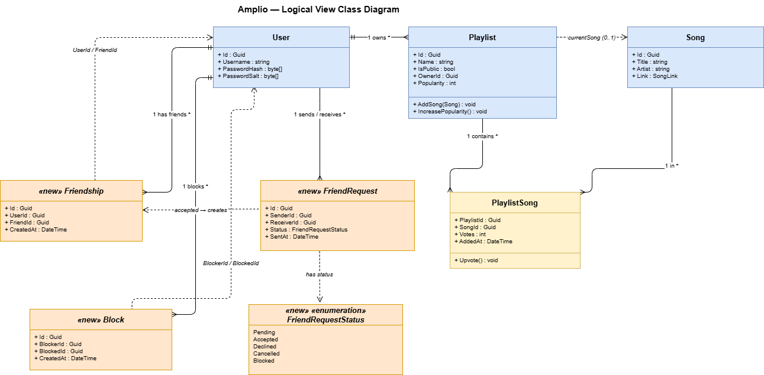
The diagram shows the classes that directly participate in the Friend System. The existing classes are shown in blue: User, Playlist, Song, and PlaylistSong — a join class that stores per-song vote counts and the time the song was added. Playlist connects to Song through PlaylistSong (many-to-many), and holds an optional reference to its currently active song. A User owns multiple playlists.
The classes highlighted in orange are new — added as part of this iteration. FriendRequest links two User records via SenderId and ReceiverId, tracking status through the new FriendRequestStatus enum (Pending, Accepted, Declined, Cancelled, Blocked). An accepted request creates a new Friendship record. The new Block entity records who blocked whom — blocking automatically removes any existing friendship (FR-25) and prevents new friend requests from the blocked user (FR-26)

State
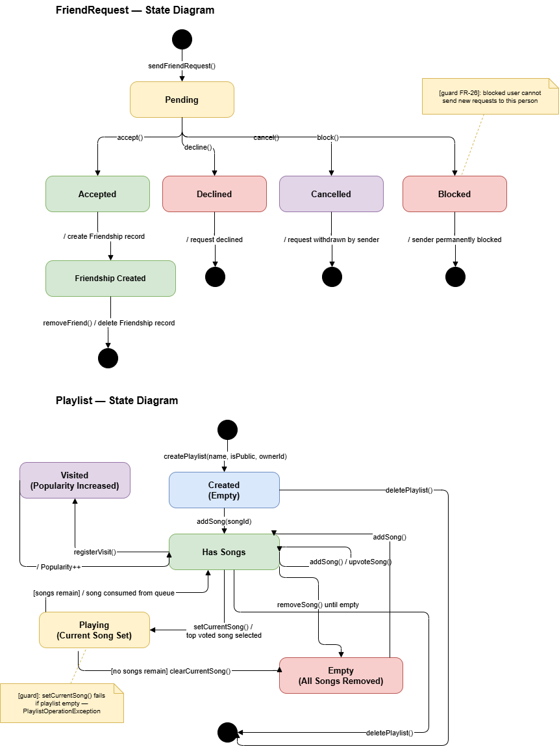The state diagram covers two domain objects. The FriendRequest state diagram is new — introduced as part of this iteration's Friend System. Once sent, the request starts in Pending. From there it can be accepted, declined, cancelled by the sender, or transition to Blocked if the receiver blocks the sender. Acceptance automatically creates a Friendship record. A blocked user cannot send new requests to the same person.
The Playlist state diagram reflects the existing behaviour. A newly created playlist starts empty. Adding the first song moves it to Has Songs, where voting and visits happen. Calling setCurrentSong() picks the top-voted song, sets it as active, and removes it from the queue — moving the playlist to Playing. If songs remain it goes back to Has Songs, otherwise back to Empty. Trying to play when already empty throws a PlaylistOperationException.

Information model
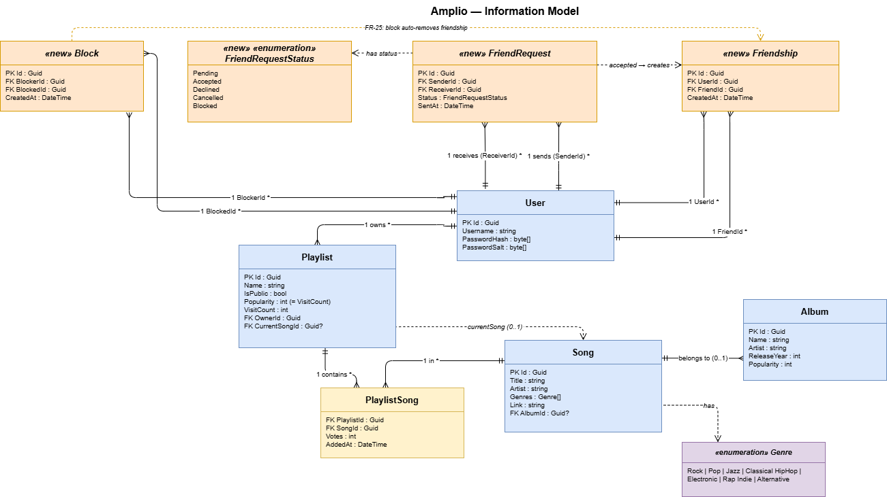The information model shows the conceptual structure of the system — entities and their relationships, without implementation details. The existing entities are User, Playlist, Song, and Album. PlaylistSong is an existing join table with extra attributes (votes, timestamp). The orange entities — FriendRequest, Friendship, and Block — are new additions introduced in this iteration. Genre and FriendRequestStatus are enumerations, where FriendRequestStatus is also newly added.
A User owns multiple playlists, can send and receive friend requests, have friendships, and block or be blocked by others. A Playlist connects to songs through PlaylistSong (many-to-many). A Song optionally belongs to an Album. A playlist also holds an optional reference to its currently playing song.

Development View
  - Component diagram

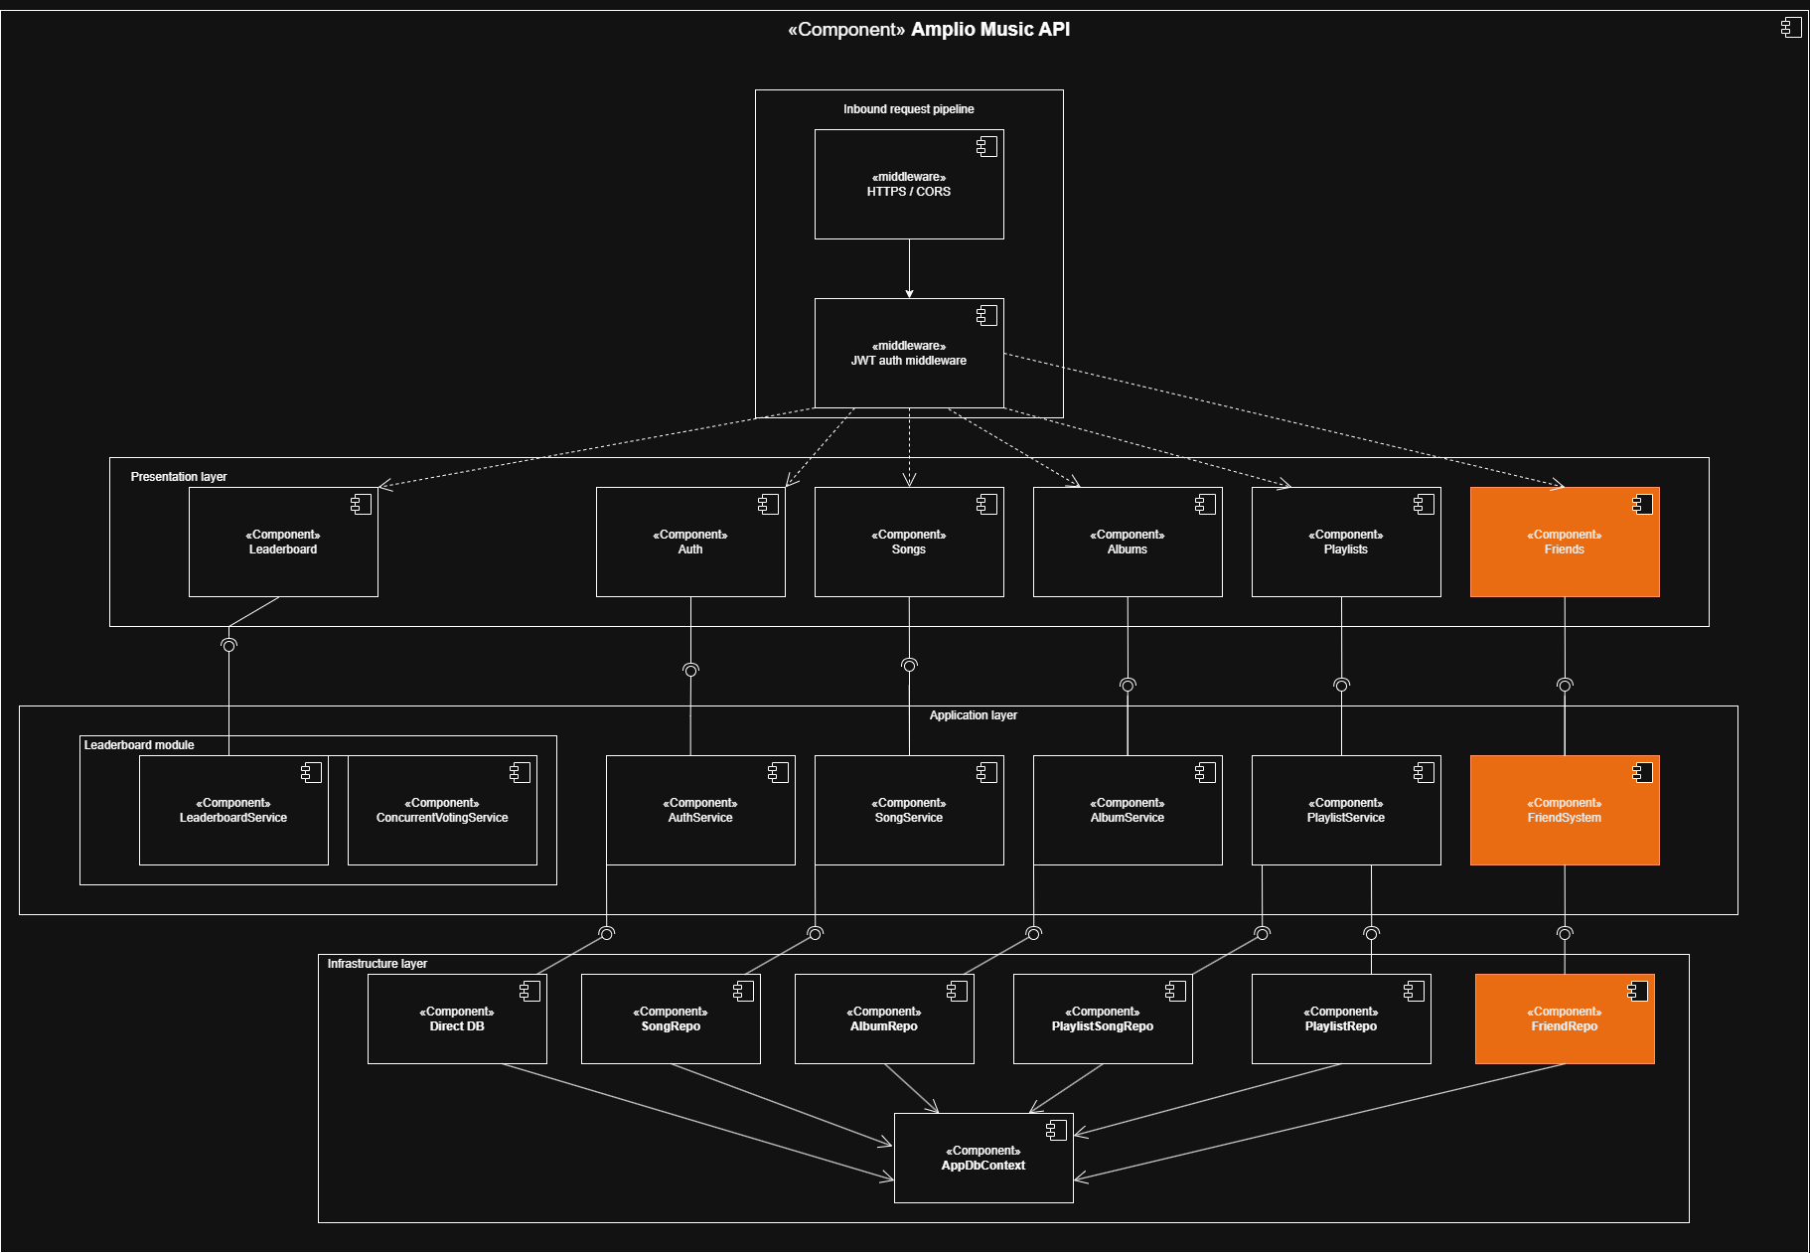
Inbound Request Pipeline: Acts as a security gate. It contains HTTPS / CORS for encrypted access and JWT Auth Middleware to validate users and inject their identity into the request before it reaches any logic.
Presentation Layer: Contains the entry-point Controllers. The Friends Controller (Orange) is the new controller for social interactions, following the same pattern as existing components like Songs and Playlists.
Application Layer: Houses the core business logic. Each service is accessed via UML Assembly Connectors, ensuring that the API depends only on abstractions rather than concrete code. The FriendSystem manages the logic for friendship requests and status.
Infrastructure Layer (Data): Handles persistence. The FriendRepo (Orange) joins the existing repositories to manage database queries. All repositories utilize a single AppDbContext to communicate with the PostgreSQL database.

Process View
  - Sequence diagram
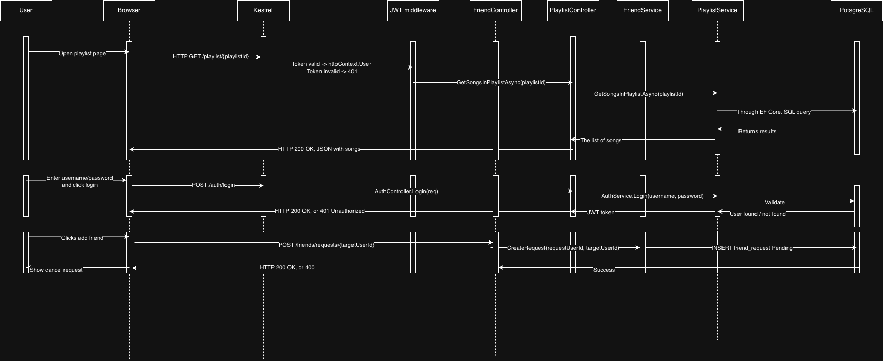
The diagram illustrates the runtime interaction flow between the client, backend API, and database for three main features: authentication, playlist retrieval, and sending friend requests.
A user interacts through the browser, which sends HTTP requests to the server (Kestrel). Authentication is handled via a login endpoint, where credentials are validated and a JWT token is issued. This token is then used by subsequent requests and verified by the JWT middleware, which either attaches the user to the request context or rejects it with a 401 response.
For playlist retrieval, an authenticated request is routed through the controller and service layers. The PlaylistService fetches the playlist songs via Entity Framework, executing a SQL query on PostgreSQL and returning the results back through the stack as a JSON response.
The friend request flow follows a similar path: the client sends a request, which is processed by the FriendController and FriendService. A new friend request is created and stored in the database with a “Pending” status, and a success response is returned to the user

  - Activity diagram
    - Open Playlist diagram

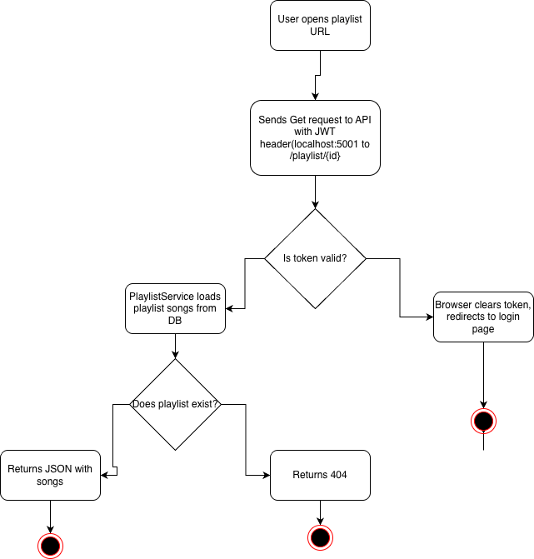
The diagram shows the flow of retrieving a playlist when a user opens a playlist URL, including authentication and validation steps.
The process starts when the user navigates to a playlist page, triggering a GET request to the API with a JWT token in the request header. The system first validates the token. If the token is invalid or expired, the browser clears it and redirects the user to the login page.
If the token is valid, the request proceeds to the PlaylistService, which loads the playlist and its songs from the database. The system then checks whether the requested playlist exists. If it does, a JSON response containing the playlist data and songs is returned to the client. If not, a 404 response is returned.

    - Add Friend diagram
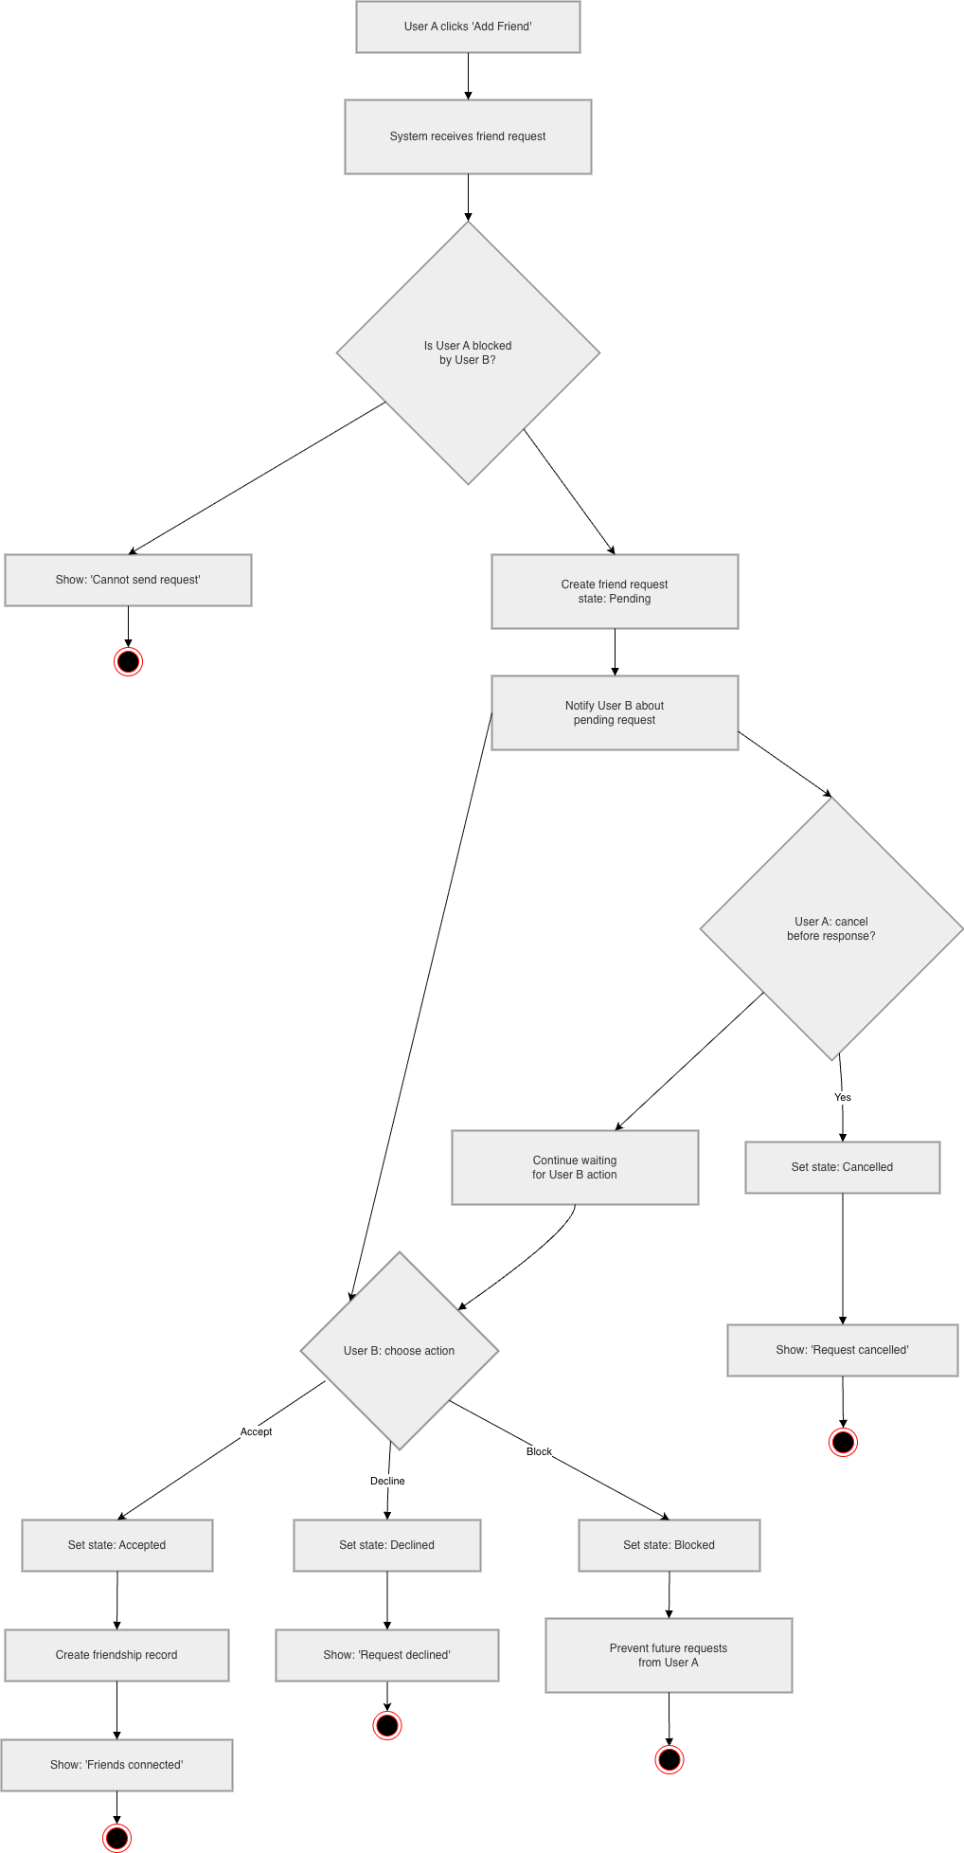
The diagram illustrates the flow of sending and handling a friend request between two users, including validation, state transitions, and possible outcomes.
The process begins when User A clicks “Add Friend,” and the system receives the request. Before creating the request, the system checks whether User A is blocked by User B. If so, the request is immediately rejected and a “Cannot send request” message is shown.
If the request is allowed, a FriendRequest is created with a Pending state, and User B is notified. At this point, two parallel paths are possible. User A may cancel the request before a response, which transitions the request to Cancelled and displays a confirmation message.
Accept the request state becomes Accepted, a Friendship record is created, and both users are connected.
Decline the state becomes Declined, and the requester is notified.
Block the state becomes Blocked, and future requests from User A are prevented.

Physical View

Deployment diagram
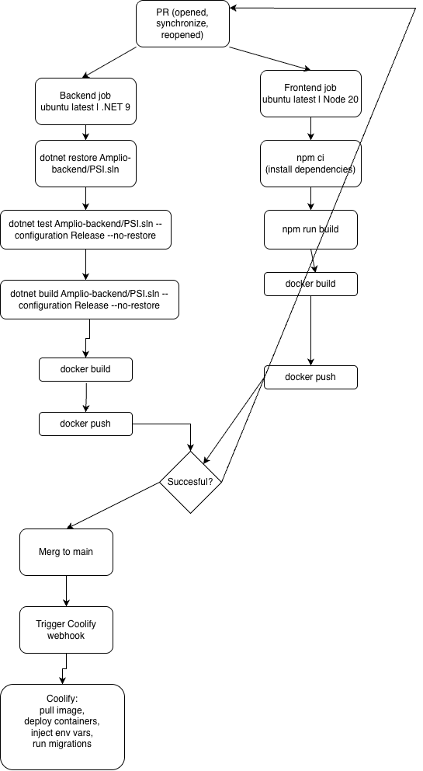
The diagram presents the CI/CD pipeline triggered by pull request events (opened, synchronized, or reopened), showing how both backend and frontend are built, tested, and deployed.
Once a PR is created or updated, two parallel jobs run. The backend job uses a .NET 9 environment on Ubuntu: it restores dependencies, runs tests in Release configuration, builds the solution, and then creates and pushes a Docker image. In parallel, the frontend job runs on Node 20: it installs dependencies, builds the application, and similarly builds and pushes its Docker image.
After both jobs complete, a success check determines whether the pipeline can proceed. If all steps pass, the changes are merged into the main branch. This merge triggers a Coolify webhook, which handles deployment by pulling the latest Docker images, starting containers, injecting environment variables, and running any required database migrations.

  - Network diagram
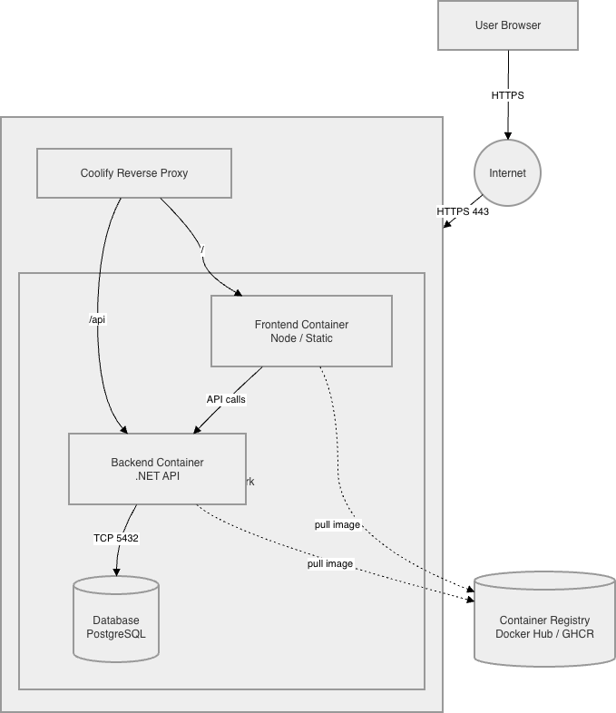
A user accesses the system through a browser over HTTPS, with requests entering through the internet on port 443. These requests are handled by the Coolify reverse proxy, which acts as the entry point and routes traffic based on the path. Requests to the root are forwarded to the frontend container, which serves the static Node-based application, while requests to /api are routed to the backend .NET API container.
The frontend communicates with the backend via internal API calls, keeping all service-to-service communication within the container network. The backend container connects to a PostgreSQL database over TCP (port 5432) to store and retrieve application data.

Use Case View
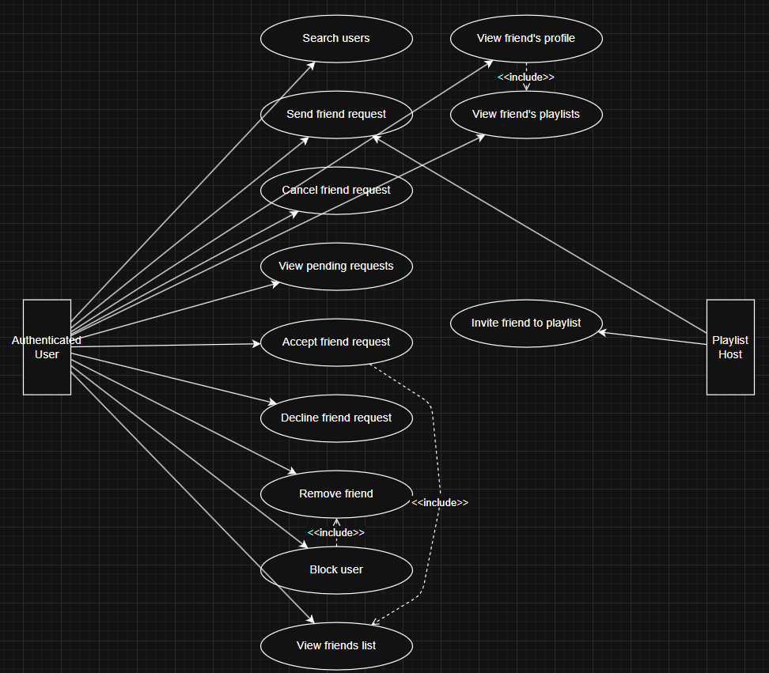
The Friend System introduces two actors. The Authenticated User is any logged-in user who can search for other users, manage friend requests (send, cancel, accept, decline), remove friends, block users, and browse a friend's profile and public playlists. The Playlist Host is a specialisation of the Authenticated User who additionally can invite friends directly to their playlist without sharing a join code. Blocking a user implicitly includes removing any existing friendship, so the block use case extends the remove friend behaviour. Accepting a friend request automatically results in both users appearing in each other's friends list, which is captured as an include relationship from the accepted use case.

Traceability
Requirements to Views

Requirement | Source | Logical View | Dev View | Process View | Physical View
Send / cancel friend request | FR-02, FR-09 | FriendRequest, FriendRequestStatus | FriendController, FriendService | State diagram, Activity Diagram | -
Accept / decline friend request | FR-07, FR-08 | FriendRequest,Friendship | FriendController, FriendService | State diagram, Activity Diagram | -
Persistent friendships | FR-13 | Friendship | FriendService, FriendRepository (planned) | State diagram, Activity Diagram | PostgreSQL migration
Remove friend | FR-10 | Friendship | FriendController, FriendService | Activity Diagram | -
Block user | FR-24, FR-25, FR-26 | Block | FriendController, FriendService | Activity Diagram | PostgreSQL migration
User search (username) | FR-01 | User.Username | FriendController, FriendService | - | Indexed column
View friends list | FR-14, FR-15 | Friendship, User | FriendController, FriendService | - | -
View friend profile & playlists | FR-18, FR-19 | User, Playlist | FriendController, PlaylistService | - | -
Invite friend to playlist | FR-21, FR-22 | Playlist, User | PlaylistController, FriendService | - | -
Hide blocked profiles/playlists | FR-27 | Block | FriendService | Activity diagram | -
Rate limiting | NFR-09 | - | FriendService (service layer) | - | -

View to View cross-references

Element | Logical View | Dev View | Process View
FriendRequest | FriendRequest class, FriendRequestStatus enum | FriendService, FriendController, FriendRequesRepository (planned) | State diagram (Pending -> Accepted/Declined/Cancelled/Blocked)
Friendship | Friendship class | FriendService, FriendRepository | State diagram (created on Accept)
Block | Block class | FriendService, FriendController | StateDiagram
User search | User.Username field | FriendController, FriendService | -
Playlist Invitation | Playlist, User relationship | PlaylistController, FriendService | -
JWT Authentication | User entity | JWT Middleware (cross cutting) | Sequence Diagram

